WAVE MOTION

Waves transmit energy from one point to another in a substance (called a medium) without the particles of the substance moving with it.

This leads to the following definition.

Wave motion: a disturbance or vibration that transmits energy without the movement of
matter from one point to another.

Waves that require a medium are called mechanical waves.

e.g. Sound, water waves, waves in strings and springs.

Waves that don't need a medium are called electromagnetic waves.

e.g. Light.

There are two types of mechanical waves.

Transverse wave - particles move perpendicular (up and down) at right angles to the
direction of the movement of the wave.

e.g. Water waves.

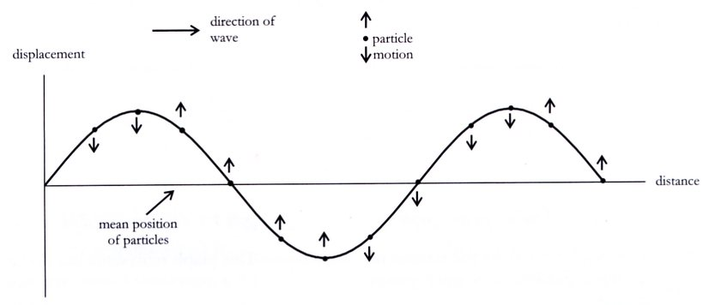

Longitudinal wave - particles move parallel (back and forward) in the same direction as the
direction of the movement of the wave.

e.g. Sound waves

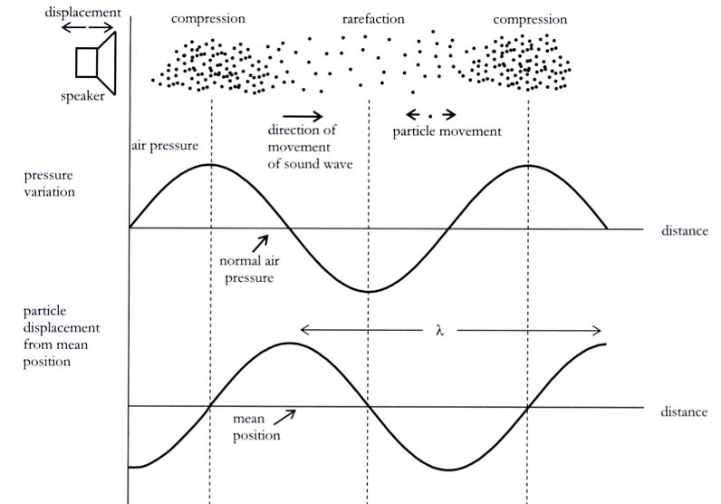

Wave graphs

Wave motion can be represented by a displacement/ time graph or a displacement/distance
graph.

• Displacement / Time

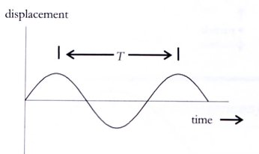

This graph represents the motion of a single particle as a wave passes through it.

The crests and troughs represent the particle's maximum displacement from its mean position.

T is the period of vibration - time taken for one complete oscillation (up-down and back to
start position).

• Displacement / Distance

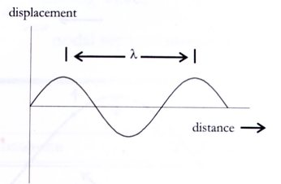

This graph represents the movement of a number of particles from their mean position at
some instant in time.

Think of it as a "snapshot" or photograph that shows how the displacement of the particles of
the medium varies over the distance at that instant.

λ represents the wavelength of the wave.

Describing Wave Motion - Important Terms

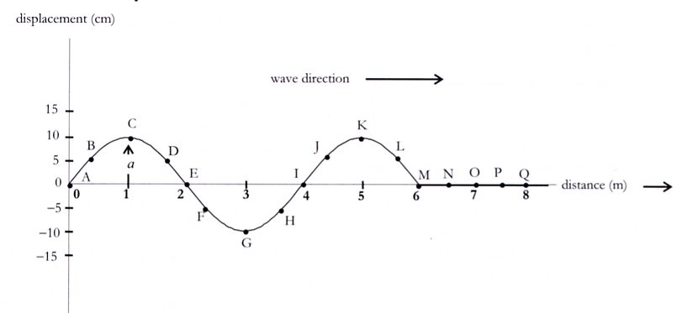

Wavelength (λ) The distance between any two crests or troughs.

e.g. The distance between points C & K, A & I, etc.

Amplitude (a) The maximum displacement of a particle from its mean (normal) position.

i.e. Height of a crest or depth of a trough.
The amplitude of the wave shown is 10 cm.

Frequency (f) The number of complete vibrations (or waves) per second.

The unit of frequency is the hertz (Hz).

Period ( T) The time taken to complete one vibration (or to produce one complete wave).

